**Rabbit**

【Business Card】Rabbit

Scientific name: Rabbit - the collective name for all animals under the family Lagodae.

Aliases: Rabbit, Rabbit, Missing Nose, Three-petal Mouth, Leaping Cat, Yue Jing, Bright Vision, Mao Animal, etc.

Nickname: Fly on the Grass

Status: One of the animals most familiar to humans; also one of the most commonly domesticated.

Lifespan: The lifespan of wild rabbits is generally about 10 years, and the lifespan of domestic rabbits can reach up to 18 years.

Body length: generally about 20 cm to 50 cm, the largest can be as long as 120 cm.

Weight: Usually the weight is 1 kg to 7 kg, and the heaviest can reach 45 kg.

Sound characteristics: usually make some small "humming" sounds, which are used to express happiness and comfort; use "噗噗" and "呲味" to issue warnings; when encountering danger or being hurt, they will emit Screaming.

Fur color: black, white, gray, brown, brown, etc.

Appearance features: The little cute rabbit is so cute; two long ears, listening to the octagonal sounds; a pair of round eyes, insight into thousands of miles; three-petal mouth, big die, chewing non-stop from morning to night; short front legs, hind legs Strong and strong, good at jumping and long-distance running; big belly and small tail, soft and waxy, which makes people pitiful.

Life habits: Rabbits are born cowards and are easily frightened; they like to eat and move around at dusk and at night; they are omnivorous, mainly plant-based, and they need to grind their teeth continuously; they love to be clean, but they have the habit of eating their own soft stools.

Population status: Rabbits are widely distributed around the world. Most species live in Asia, Africa, and North America. The population is stable, and some species are endangered species, such as the volcanic rabbit in Mexico and the dwarf rabbit in the Columbia Basin.

Cultural background: Rabbits have a place in the culture of many countries. In China, rabbits are always associated with the moon. The continuation of life. Nowadays, people have bred more and more pet rabbits, making rabbits one of the important family pets.

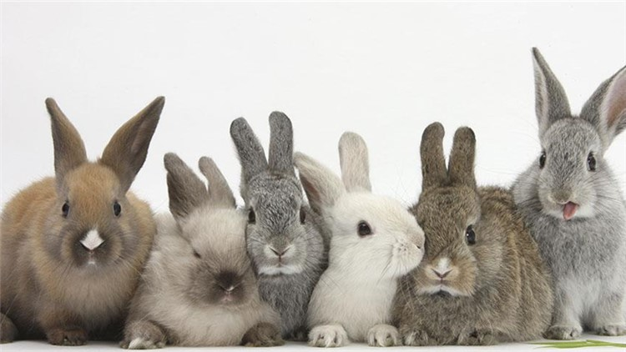

There are so many bunnies, there is always one that will hit you

[The big rooster (played by Da Zhuang) complained to the little rabbit (played by Qiaoqiao): "Sister Rabbit, tell me, we have been old neighbors for so many years, and our identities are the same. Cute pet, I have entered the house, and I have to continue to stand guard outside the door?" Sister Rabbit stretched out her little paw and rubbed her round face: "Brother Rooster, you can't be as tough and capable as you, you have to be as soft as me Only soft, fragrant humans will like it, and the most important thing is to learn to be cute."]

【Questions and Answers】

Why are the bunny's eyes red?

First of all, we have to figure out that not all rabbits have a pair of red eyes, that is just the exclusive color of the little white rabbit. What color are rabbit eyes? The answer is simple, that is what color fur goes with what color eyes. The "pigment" in the rabbit's body determines the color of its fur and eyes. A rabbit with melanin has black fur and black eyes. Similarly, a rabbit with gray fur and gray eyes must have gray pigment in its body. The little white rabbit is quite special. Its snow-white body does not contain "white pigment" but has no pigment (that is, what we call albinism), so its eyes are also transparent. Because of this, we can see it clearly The color of the capillaries in the fundus - red, the color of blood, this is the reason why the little white rabbit has red eyes. It turns out that the most popular little white rabbit is a real "beauty without makeup".

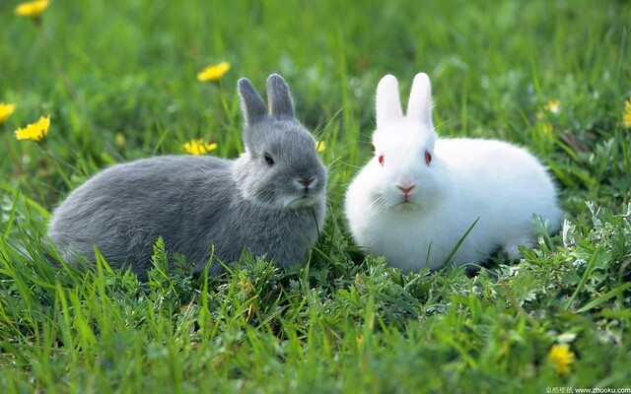

gray rabbit with gray eyes; white rabbit with red eyes

[The famous Black Rabbit director (played by Xiao Baike) went to the art school to find an actor, and wanted to make a rabbit movie for humans. When he entered the school, his eyes were full of white rabbits. The director slapped the table angrily: " What is going on, are all the rabbits in the school sick?!" A little gray rabbit wrapped in a white cloak (played by Xiao Mimu) stood up and said in a low voice, "Didn't everyone hear that it was filmed for humans to see?" I think it should cater to their taste, so I put on white makeup." The director tore off the white cloak of the little gray rabbit, and said loudly: "You silly children, I just want to shoot a colorful Rabbit World, let humans know what is the real health and beauty of Rabbit World.”]

Isn't the rabbit's eyesight particularly poor, or how could it crash into a tree?

Rabbits do have a slightly different vision. As animals at the bottom of the food chain, small rabbits in the wild must be vigilant at all times to avoid being stared at by predators. Therefore, in addition to being equipped with big ears to listen in all directions, they have also evolved eyes with a 360-degree panoramic scanning function , You can observe the enemy's situation at any time while eating. The two eyes of the rabbit are separated on both sides of the head, and each eye has a viewing angle of nearly 180 degrees. The ability of farsightedness is very strong, and it can see extremely far places, allowing it to detect all suspicious and dangerous attacks as soon as possible. Therefore, if you want to approach it quietly from behind or from the side, it is a daydream, and you will be spotted and escaped by it every minute. The only possible direction is directly in front of the eyes and nose, which is a blind spot of the rabbit's vision. Fuzzy, no three-dimensional sense, often need to use the sense of smell to help identify close objects. When the rabbit in the woods is running at a high speed, it will crash into a tree before it can be carefully identified. This is the story of "waiting for the rabbit". In addition, rabbits are still colorblind and can't distinguish several colors at all, so you don't need to dress up in front of your cute bunny, and if you want the bunny to remember your appearance, you have to Keep in mind that "distance produces beauty", the farther you are from it, the more it can see clearly.

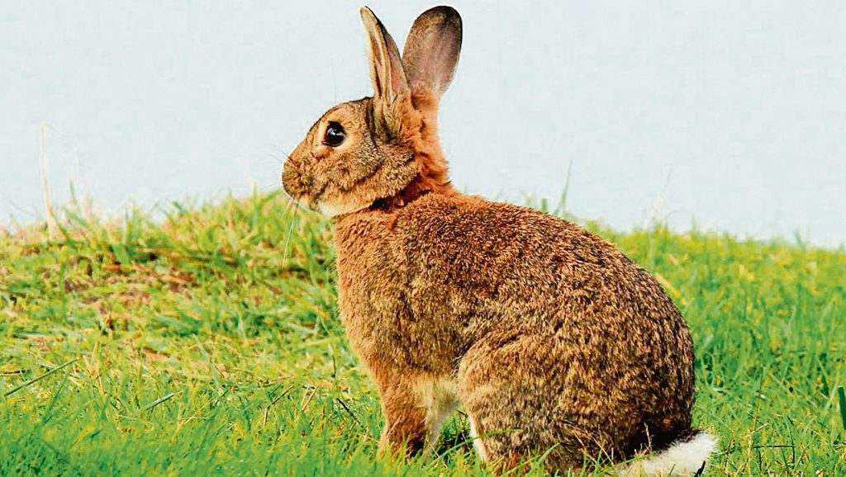

Do you think it is in front of your eyes? No, no, no, it's staring at you.

[The owner brings back a little rabbit to keep company with the kitten at home. The little cat (played by Xiao Mimi) greets and chats with the little rabbit (played by Qiaoqiao) enthusiastically, but the little rabbit always faces the cat sideways, as if With a casual look, Miao Mi asked loudly angrily: "Miss Rabbit, are you too arrogant? I've been telling you for a long time, but you haven't even looked at me." Stepping forward, he said aggrievedly: "Mr. Kitty, you have wronged me. My eyes can only see things from the side. I have to look sideways at you just to see you and remember your appearance."]

Why do rabbits have three-petal mouths? What other animal also has a three-petal mouth?

In fact, rabbits don't want to look so different, and it doesn't feel good to be pointed at by others. Unfortunately, rabbits are born unsatisfactory, nine out of ten, in order to survive, it doesn't matter if they are ugly or ugly, let alone Many people like their three-petal mouth shape. Rabbits mainly eat all kinds of grass and grass roots. Even if you eat your stomach round, it is still grass, and your energy cannot keep up. Over time, the rabbits found that eating the grass and grass roots close to the ground was exhausting, and their lips were always in the way. So, a rabbit thought of a way to split the upper lip in half and let the front teeth squeeze out from the gap in the middle. Now it is quick and convenient to eat grass. The other rabbits laughed at it at first, but gradually They discovered the benefits of it, so they followed suit one after another, and passed on the characteristics of the three-petal mouth to their children. In this way, from generation to generation, the rabbit completely evolved into a three-petal mouth. Similarly, camels living in arid areas have evolved three-petal mouths because there are few tall plants on the ground in arid areas, which makes it easier for them to eat surface plants and underground rhizomes.

In addition, rodents have evolved three-petal mouths for the convenience of grinding their teeth; although cats also have three-petal mouths, the two halves of the upper lip cannot be completely separated, but can be expanded to the greatest extent. , baring its canine teeth to bite its prey.

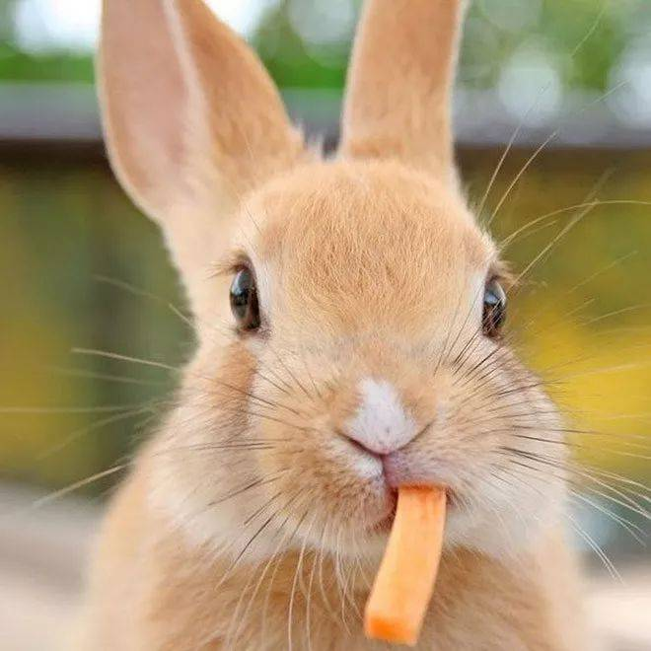

How fertile is a female rabbit?

Rabbits have too many natural enemies in nature. If you pick any carnivorous animal, it is guaranteed to have the name of rabbit in its recipe. Therefore, for rabbits, they must have a bit of hard work to survive in difficult situations. After a series of attempts such as escaping, counterattacking, digging holes, etc., the rabbits found that these are not a perfect solution, and there is only one most effective way, that is to have as many babies as you can, so that you can't eat them all. endlessly. As a result, the female rabbit has evolved the alternate use of double wombs, which speeds up the frequency of reproduction, and at the same time shortens the period of pregnancy and lactation. After such a magical operation, a female rabbit can give birth to an average of 6 litters of rabbits a year, with 3 litters per litter. ~7, plus the little rabbits can give birth 4 months after birth, so the little rabbits at the beginning of the year can be mothers in half a year, and can be promoted to grandmothers by the end of the year, and have a family with a large number of rabbit members. No wonder the twenty or so rabbits introduced to Australia in 1859 developed into a serious rabbit disaster 70 years later in an environment where there were no natural enemies, and its bad influence has continued to the present.

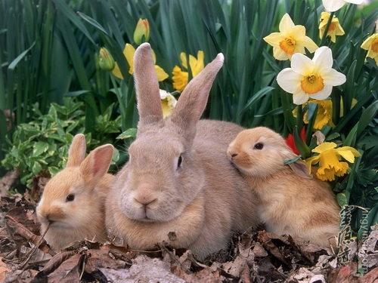

**Where do domestic rabbits come from? Will domestic rabbits become wild rabbits naturally?**

The mystery of the life experience of domestic rabbits has been studied by scientists for hundreds of years. Although there are still some disputes, it is generally agreed that the ancestors of all domestic rabbits in the world are wild "hole rabbits" in Europe. That's right, all kinds of rabbits that we can see around us are basically domestic rabbits. Although they reproduce on Chinese soil, they are indeed "foreign rabbits".

Domestic rabbits will not turn into wild rabbits after they are released into the wild. In the case of many natural enemies, they often lose their lives. In fact, domestic rabbits and hares are two different branches of the rabbit family. The domestic rabbit is a branch of the rabbit, and the rabbits of this branch are good at digging holes and living and multiplying in the cave; the hare here does not refer to rabbits living in the wild, but another branch family named "hare". , they have stronger running ability, have bigger and longer ears, do not dig holes, only live in nests in the wilderness, and their cubs can stand after birth. Animals belonging to the rabbit family and animals belonging to the hare cannot reproduce to produce offspring. Therefore, even after thousands of years, the domestic rabbits scattered all over the world still maintain their pure foreign blood.

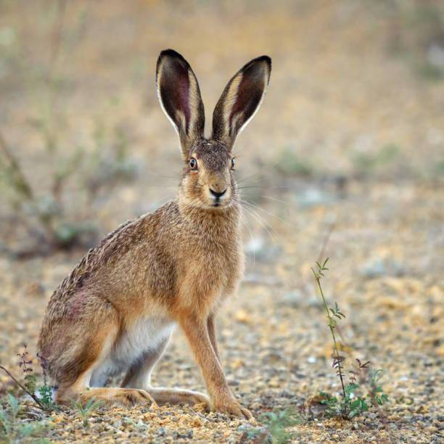

I am a hare, I like to walk alone, I have bigger ears, longer legs, a slender figure, and I am very good at running.

**[Interlude version - interesting cold knowledge]**

The rabbit's tail is a bit long

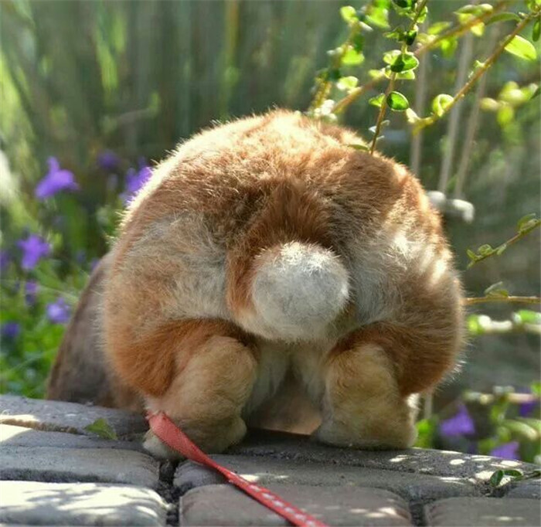

"Short, round, fluffy, like a little fur ball." Is this the tail of a little rabbit in your impression? If you nod, then the next thing you're going to be eye-popping. Let's take a look at the real tail of the rabbit.

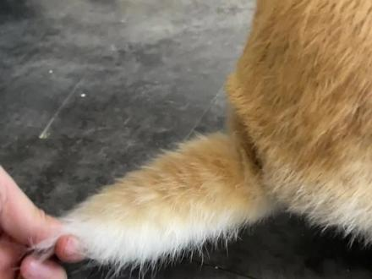

What? ! The bunny's tail is not round? That's right, the tail of a small rabbit is flat and long, usually 5 or 6 centimeters in length, while the tail of a giant Huaming rabbit can be as long as 17 centimeters. However, the tails of rabbits we usually see are all spherical? That's because they are used to curling their tails up into a small ball. Curling the tail is a means of self-protection for rabbits, especially in the wild. Curling the tail can avoid being bitten by predators and increase the chance of escape. Only when the rabbit is completely relaxed, they will put the curled tail The tail spreads out. So, if you want to know if your cute bunny pet feels safe around you, just observe its little tail.

**Knock on the small blackboard, I have six "big dies"**

Rabbits, like other rodents, have very conspicuous incisors. However, ordinary rodents have a total of 4 incisors, and rabbits have two other incisors hidden behind the upper incisors, so there are 6 incisors in total. Big Die. Similarly, the incisors of rabbits also have the characteristic of unlimited growth. Rabbits must eat more coarse fiber to fill their stomachs and shorten their teeth at the same time. The work of grinding teeth must not be neglected at all, otherwise, once you get lazy, the big die will grow out of control and become crooked ivory. The upper and lower teeth cannot bite, and you will not be able to eat. You can only be a poor starved rabbit. Therefore, you can always see the rabbit's three-petal mouth constantly wriggling, either eating or grinding its teeth. It is truly endless life and chewing. I also want to tell you quietly, the saying "a rabbit bites when it's in a hurry" is not casual, the rabbit's teeth are small but extremely sharp, if you provoke it, you will be sure to leave a neat wound , as cut by a knife.

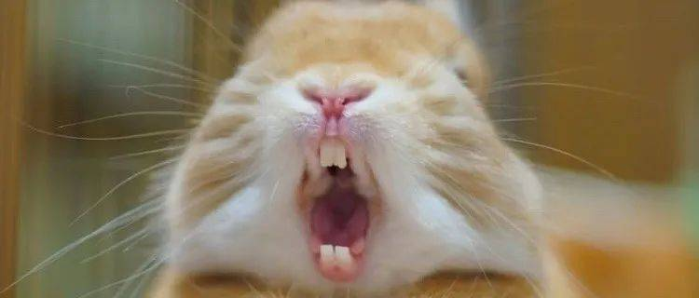

The mouth has been opened to the maximum, how can I let you see my six big dies, it is too difficult!

**Rabbit that can change clothes**

In my country's Heilongjiang and Inner Mongolia regions, there lives a kind of hare that can change clothes—the snow hare. In summer, they wear unremarkable brown summer clothes to hide themselves well in the fields; in winter, when the sky is full of snow, they will wear snow-white cotton clothes, leaving only a little brown on the ear tips and eye circles as decoration. This is the only rabbit that can molt in our country, and it is a second-class national protected animal in our country.

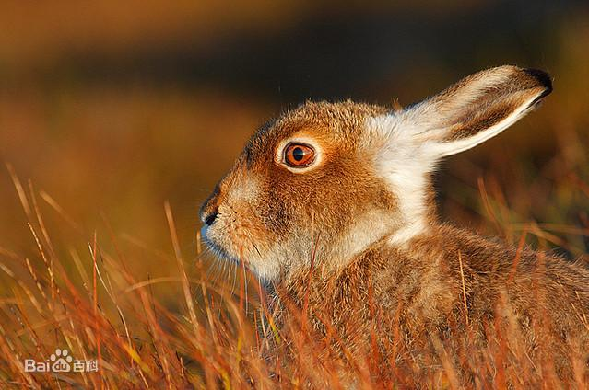

summer dress

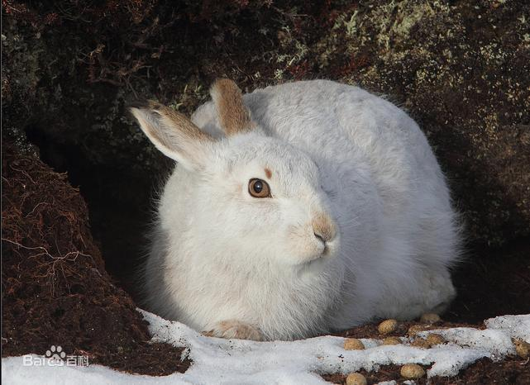

winter clothes

**The Intangible Cultural Heritage of Old Beijing——Grandpa Rabbit**

Rabbit is a unique handicraft of old Beijing. It has been handed down since the Ming Dynasty. It is a small gadget made of mud based on the image of a rabbit. It has many patterns and is painted with festive and lively colors, implying auspiciousness and happiness. It can be enshrined or played with. It is a symbol of the Mid-Autumn Festival and a part of the traditional culture of old Beijing.

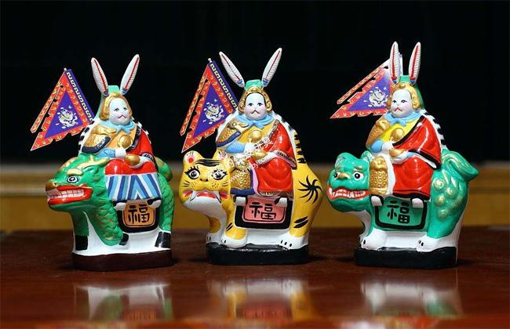

**The world's oldest trademark**

Unexpectedly, the little rabbit is actually the first advertising star in our country. As early as the Northern Song Dynasty, in Jinan, Shandong, there was a needle shop named Liu. They published an advertisement using "White Rabbit Pounding Medicine" as their trademark. The location and name of the shop were written on the top of the advertisement "Jinan Liu Home Kung Fu Needle Shop", in the middle is the pattern of a white rabbit pounding medicine, and it is marked "recognize the white rabbit in front of the door as a memory"; at the bottom of the advertisement, a series of product features are written-good raw materials, excellent technology, easy to use, Wholesale discounts available. Although I don't know what the relationship between rabbit pounding medicine and sewing needles is, this ingenious way of attracting customers really attracts attention and makes this shop famous for a while.

According to research, the White Rabbit trademark is the earliest trademark in my country and in the world. The entire trademark is engraved on a small copper plate using copper plate printing technology. Fortunately, this copper plate has been preserved intact. It is currently stored in the Chinese History Museum. Interested students can visit it.



**Shed blood for human beings and dedicate themselves to science**

What did the little rabbit do for humans? If you don't talk about it in detail, you must not realize their efforts. There must be a purpose for humans to domesticate animals, such as rabbit fur, rabbit skin, rabbit meat, for experiments, and as pets. It is no exaggeration to say that every rabbit is a proper slash youth with multiple jobs. As a big province of raising rabbits, Sichuan is also known as a big province of eating rabbits. Every year, 300 million rabbits are eaten. The number is so amazing, we have to say thank you. There are also those laboratory rabbits who are brave enough to dedicate themselves to the cause of science. The success of the research on rabies vaccine is due to the sacrifice spirit of rabbits and horses. Nowadays, the rise of pet rabbits has finally given rabbits a better career choice. If you have the opportunity to raise a cute little rabbit, please promise me that you will love and take care of them.